Transcranial Direct Current Stimulation (tDCS) Device

Donghyun (David) Seo, Carim-Sanni Sobur, Eric Luu, Radhanath Purakait, Shalih Miah

City College of New York

BME 4500: Biomedical Engineering Senior Design

Sponsor: Dr. Marom Bikson

Faculty Mentor: Professor Alessandra Carriero

TA: Jack Twiddy, Evan Azoulay

**Abstract**

The goal of this project is to create an easy to use disposable tDCS device that will come in a package requiring minimum setup. The target audience of this device is home consumers suffering from depression and anxiety. The design of the device was split into three components, headgear, electrode and circuitry. The selected headgear with the best ergonomics was the cap headgear. Next, the selected electrode with the best current distribution was the sponge electrode. Finally, the selected circuit is able to be powered with 9V batteries, outputs a current between 1-2 mA and includes a ramp up and down feature at the beginning and end of the stimulation.

**Background**

Transcranial direct current stimulation (tDCS) is a form of neurostimulation where low levels of constant current is applied to certain areas of the brain. The brain is comprised of a complex network of nerve cells also known as neurons. Neurons are responsible for processing and transmitting signals throughout the brain and react to everything that happens in our bodies. Neurons communicate by sending small electrical, and chemical impulses called synapses through the cell body with the help of neurotransmitters. Electrical synapses, unlike chemical synapses, conduct nerve impulses faster (approximately 10 times faster), causing information to pass from neuron to neuron more quickly [5]. The process of polarization and depolarization of the cell bodies and the synaptic connections can be modulated with direct current. An anodal stimulation (negative voltage) will tend to produce more frequent neuronal firing and increase plasticity due to hyperpolarization of neurons, cathodal stimulation will similarly create the opposite physiological effect [19]. However, it is not clear how this physiological response relates to changes in mood and behavior as the full link has not been established [19].

The tDCS works by sending a one directional current through electrodes attached to the scalp. The placement of the electrodes can change the direction of the current and which area of the brain it affects, so where to put the electrodes is very important. The low current can alter a neuron's activity in a desired direction. This means that tDCS can strengthen or weaken the signals between neurons also known as synaptic plasticity [20]. Synaptic plasticity is linked to memory, ability to learn, and how well neurons communicate. Therefore, enhancing synaptic plasticity has the potential to enhance neuronal communication, coordination, attention span, problem solving, etc.

The tDCS was mainly developed to help patients that have experienced brain injuries. However, studies have shown that tDCS can also be used on healthy people to stimuli parts of their brain to increase their cognitive performance. Depending on what area of the brain is being stimulated studies have shown that tDCS has the capability to enhance a person’s attention span, coordination, memory, and problem-solving ability. People with occupations such as military personnels, pilots, policemen, watchmen, or anyone with job the requires focus can benefit from tDCS. Furthermore, studies also have shown that tDCS has very high potential to treat depression, anxiety, PTSD, and chronic pain [5].

The reason tDCS can be considered an important device is because most common disorders in the world that many people suffer from is depression and anxiety. Depression and anxiety are mental health disorder that is characterized by feelings of worry, fear, sadness, and loss of interest amongst other negative feels and can decrease a person’s ability to function everyday. Even the most healthiest person is subject to fall under depression and anxiety. Depression has been linked to problems or imbalances in the brain with regard to the neurotransmitters (serotonin, norepinephrine, and dopamine) [17]. A person who’s suffering from depression and anxiety have their neuron activity (transmitting signal) decreased compared to that of a normal person.

It's been estimated that around 264 million people worldwide have an anxiety disorder [6] and 322 million people worldwide live with depression [7]. In the U.S alone 18.1% of the population or 40 million adults around the age of 18 and older are affected by Anxiety disorders every year, yet only 36.9% are receiving treatment [12]. Additionally, a study was done in 2015 where it showed that 6.7% of U.S population (~16.1 million adults around the age of 18 and older) were affected by major depressive episode at least once in a year. Depression is considered a leading cause of disability in the United States [12].

As effective as tDCS seems, it has a controversial view in the scientific community. A study performed to analyze researchers’ perspective on tDCS, found that a high percentage of researchers claimed tDCS to be ineffective in terms of enhancing normal functions [11]. The study also found a disparity among the effectiveness ratings across different domains. Researchers that had tDCS as an integral part of their studies rated the effectiveness of tDCS higher than those that did not. Ethical concerns also arise because the long term effects of tDCS are unknown. Studies done using tDCS are often associated with short term simulations thus, there are a lack of studies that analyzes the long term adverse effects of tDCS.

**Principles of operation**

A tDCS device consists of an electrical circuit, a pair or more electrodes, and potentially some headgear to place electrodes properly. In order to apply DC to the brain the current must be generated at the circuit. This circuit provides a flow of electrons from the negatively charged electrode to the positively charged electrode. Sometimes manufactures may include additionally waveforms. It includes a battery and potentially some safety and regulative circuitry. Regulatory circuitry may modulate the voltage applied to the skin to maintain safe current limits. Critically there must be some measure of dosage that the circuit maintains. Dosage is understood as the current (Amperes) level and time of treatment (seconds).

The next hurdle is the actual contact point where the current meets the patient’s forehead. Electrodes of different shapes and sizes (3X5,5x5,5x7 and 5x10 depending on the montage) are used to make safe and effective contact with the human skin. The idea is that the electrode has low contact resistance to reduce the heat produced as current flows. Heat can develop due to poor conductivity and due to low contact area of the electrode [4]. Even if the electrodes are effective in passing current, they must also be positioned correctly. Positioning of the electrodes are known as montages and there are different montages for different desired treatments and mental effects [3]. For example in figure 2 (left), the anode is connected to F3 and the cathode is connected FP2, this treats depression and anxiety [25]. In figure 2 (middle), only the anode is connected to F10, and this aids in accelerated learning. In figure 2 (left), the anode is connected the F4 and the cathode is connected to F3, this reduces addictive tendencies.

Another challenge of cranial stimulation is managing a safe current. In tDCS that current is typically 2 milliamps, however to manage it, a high voltage must be used, often to overcome high contact resistance and high resistance of the brain. The resistance of the brain can change with the frequency of the signal, and it can vary over time and condition [<https://www.diva-portal.org/smash/get/diva2:488621/FULLTEXT01.pdf>], this is why a regulated current supply must be used. Typically the brain has 1.5 to 1.8 kohm resistance for DC current [30].

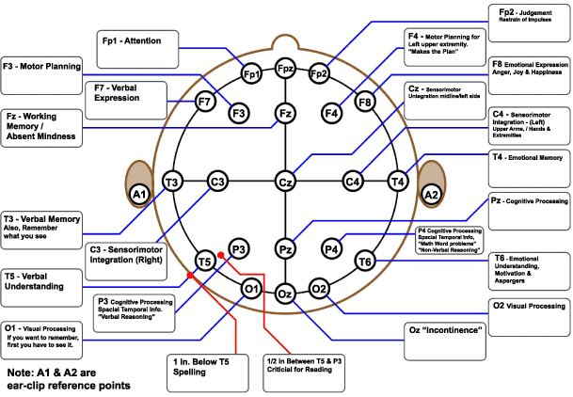Figure 1: Montage positions [28]

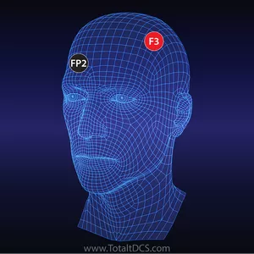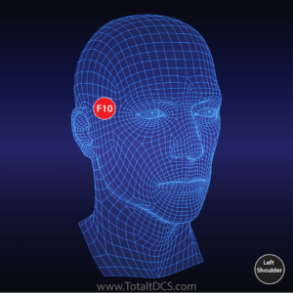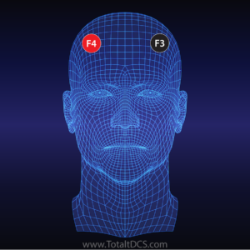

Figure 2: Different types of montages for providing aid in learning, treatment for depression and anxiety, and addiction [25]

**Who uses Transcranial Direct Current stimulation?**

tDCS can be used in a variety of settings. Today, it is primarily used for research in any subject regarding learning , drug addiction and improving focus [2],[1]. Generally the devices are actually somewhat difficult to use, they require special training to place electrodes on the head and scalp, they procedure also needs to be supervised as the circuits often do not have enough fail safe measures for layman users. This is why tDCS has mostly stayed in the clinical setting.

There have been efforts to move tDCS outside the practitioner patient relationship, currently one can even buy tdcs devices on common online retailers . However the problem of usability is a common motif throughout the different use cases. Combined with issues of misuse and safety it is evident that strides in innovation are necessary.

**Need Statement:** To find a way to make a low cost, easy to use tDCS device that can be disposed after a single dose (20~45 minutes).

**Sponsor Specifications**

There are numerous tDCS devices in the market currently, but most devices are bulky and tedious to use. Considering the tDCS devices in market currently most are not pre-packed device ready to use package without requiring any prior setup and are not easily disposable. The implementation of a disposable and single use device that is “straight out of the bag use” for home consumers particularly individuals with depression was proposed. Our sponsor has identified certain criteria that has not been meet in current tDCS devices in the market. The three major feature our sponsor is specific about is: Disposability, simplicity and single use.

1. **Disposable**: tDCS devices are used in various applications as mentioned above. This criteria is essential for users wanting a sample demo or to experience tDCS first hand without spending a lot of money. Disposability will influence the affordability of our device when compared to the other tDCS devices currently in market.
2. **Single use**: Single use is also an essential criteria, as it can be used by the patient before deciding to go for a long time use tDCS. It can also be used as demo in research meeting and conferences. Compared to an individual that uses tDCS daily and needs a long time use device, someone in this line of field trying tDCS for the first time might prefer a one time use.
3. **Simplicity and compact design**: Simplicity of this new tDCS device is important since we are targeting the home user, many of which may be unfamiliar with setting up and placing electrodes in the correct montage. Secondly the device should be compact and not hinder any movements. Setting up such devices in a intensive care unit for example should not require additional scientist to oversee the mounting [22].

There are many tDCS devices with various designs and cheap prices out there. Our target is to meet the needs of professionals and certain individuals that are used to a certain lifestyle. Those who are used to the act of “straight out of the box”, “single use” and “disposable”[22][23][24].

**Prior art**

Many tDCS devices on the market today are quite expensive (>$30) and none of the devices we found were fully disposable. However, the key feature of user operability is missing. This section describes relevant devices available in the market. There are no tDCS device that has approached the design of a disposable stimulator, so we will have to borrow inspiration from tDCS devices and disposable medical devices.

**Existing tDCS-Portable**

**Thync Device**

Thync Device is one of the self-usable portable brain stimulation devices in market currently. Unlike its competitors, which use cranial electrotherapy or transcranial direct current stimulation (tDCS), Thync doesn’t directly target the brain. The triangular module applies pulsed electrical currents to the electrodes attached to it, targeting nerves on the face. It modulates some of the hormones underlying fight to fight response by ramping these hormones up or down. Thync claims to have two effects – or “vibes”, calming or energizing [15]*.*

**Disadvantages**: The device is expensive, not disposable and its montages are restricted to the forehead + Neck and forehead + back of the ear.

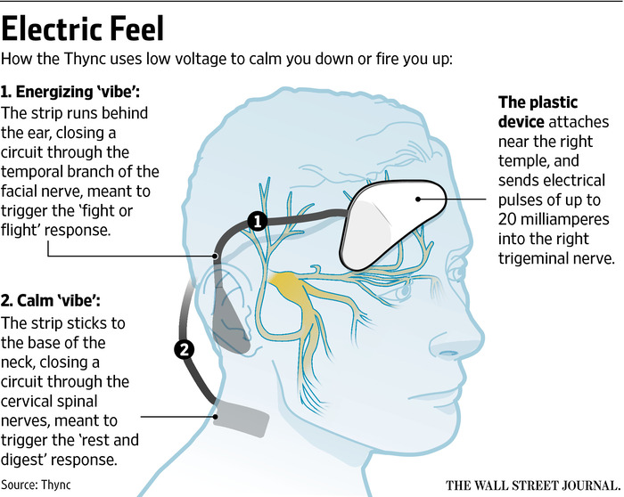

Figure 3: Thync device [17]

**The Brain Stimulator v3.0:**

The Brain Stimulator v3.0 is an example of a portable tDCS. The device features a push buttons which allow the user to increase and decrease the current flow, as well as shut off the device at any time. It has a Smart Current Ramping that creates smooth current transitions, providing comfortable tDCS sessions. The precision components and streamlined circuitry allows the device to operate at the highest 2 milliamp setting for over 90 hours. It has a replaceable battery and has a 30-minute “set & forget” session timer.

**Disadvantages:** The device is about $180 and requires a bit of expertise to set up. Electrode positioning is also prone to mistake because it requires the patient input.

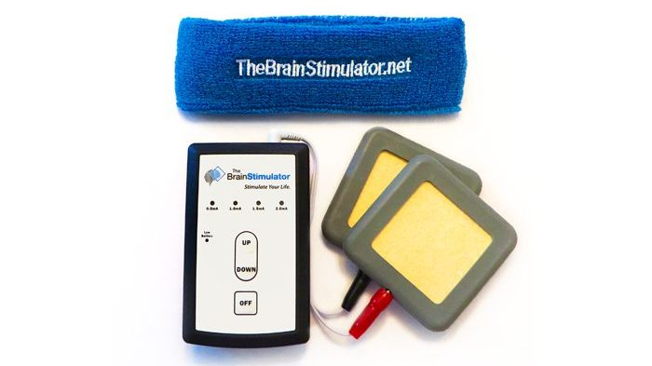

Figure 4: The Brain Stimulator v3.0 [18]

**Advantages:**

The portability and simplicity of the thync device and Brain Stimulator v3.0 could be employed in our design. Although we are proposing a design without the need of a expert and fixed electrode to avoid patient mistake. The thync device is the closest to our approach but it is expensive. Limited to one montage and not disposable.

**Soterix Medical 1x1**

Soterix Medical 1x1 system is a suite of modular components for direct current stimulation, it consists of a simple plastic headgear, snap-on sponge electrodes, and a versatile electrical circuit. This system is notable for its simple and clean design, the headgear is lightweight, flexible and versatile for most montages. It is similar to the brain stimulator V3 however it has more current dosing options and has headgear that allows one to precisely place electrodes for montages.

From this design we should take the strap design and possibly the useful markings on it. Although our design should aim to have the user do as little calibration as possible. One problem about this device is that the circuit is very expensive and has too many options. A disposable device doesn’t need to be this complex, and it’s feature set should be limited so that the circuit is also physically small.

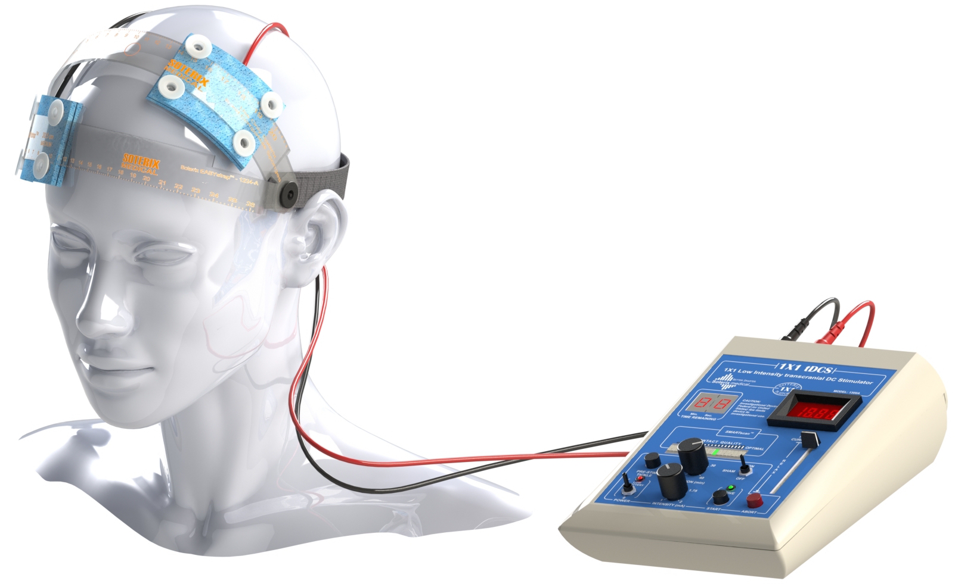

**Figure 5:** The complete soterix platform can be read more about on: <https://soterixmedical.com/research/1x1>, our sponsor’s website.

**White market devices**

There exist a grey area of devices that are cheap, but are of questionable quality, mostly because they are not actually associated with any particular company. These devices are typically used by do it yourselfers. Some are just constant current power supplies with off the shelf electrode leads to the device [26]. Some are a bit more questionable in design with high current outputs, or manual voltage control [27]. That said this niche is important to look at because these devices achieve a very low cost at the detriment of features and sometimes safety. Our device should approach the low price point of these devices as much as possible by leveraging disposability to sink costs lower.

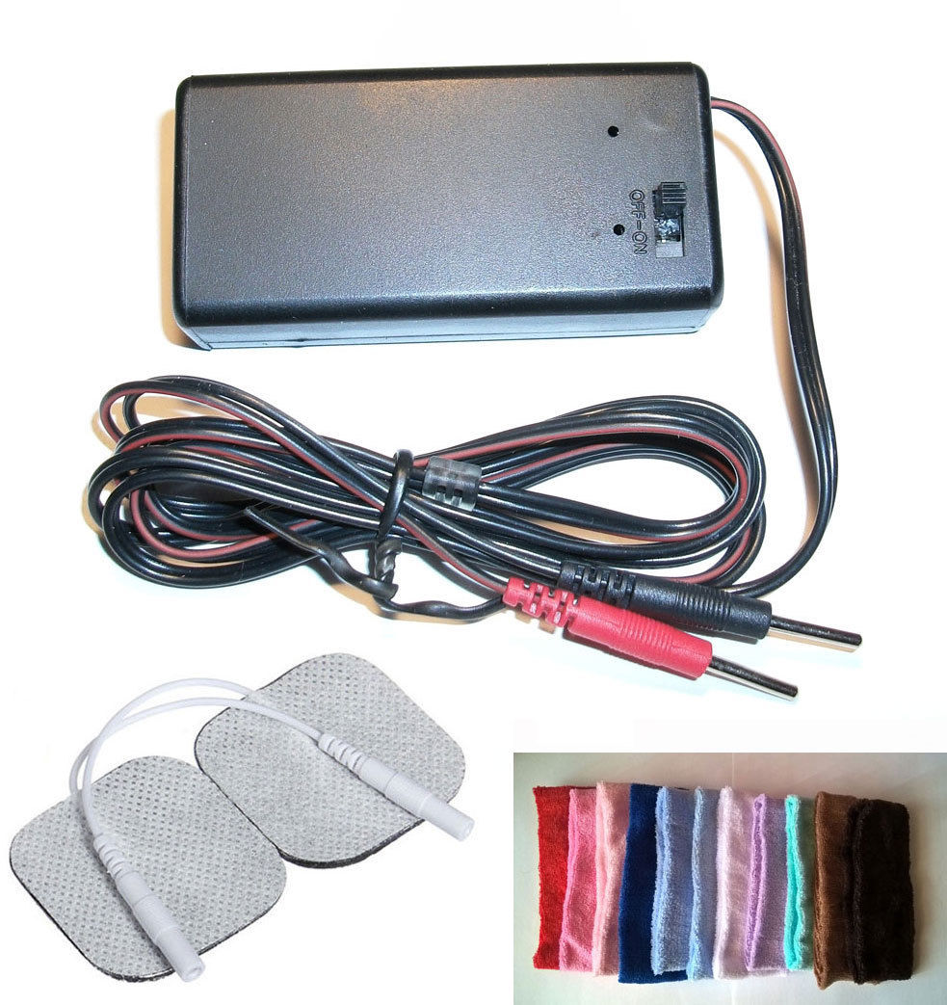

Figure 6: Go flow pro[26]

Is much like the brain simulator V3, however it is even more compact and portable. This device has a unique design in that it fits straight on a 9v battery and has simple controls for current and dose time. The advantage of this device is that it is very portable and convenient. One of the main disadvantages of the device is the high cost.

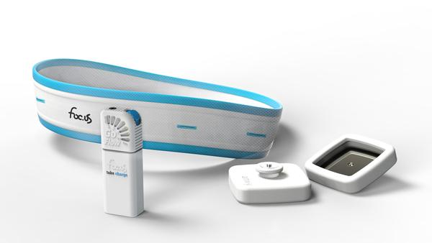

Figure 7: Focus Go flow pro[26]

Disposable muscle stimulator, (patented, not on market)

**Headgear**

Headgear application can vary in terms of design and electrode attachment. A suitable headgear would require minimal to no setup and comes ready to use. An example is the Portable EEG Electrode Locator Headgear, which includes an elastic stretchable cap that is connected to EEG electrode locators on the inside [15]. The EEG electrode locators are connected to straps that can be repositioned depending on the areas that are targeted. The device also comes with an optional plunger assembly that can be used to part the hair for preparation for electrode placement. If we can potentially combine the plunger with the cap containing the electrode locators so that no assembly would be required then the headgear for this device could be used as a guide for designing our device. This headgear design is useful for its portability

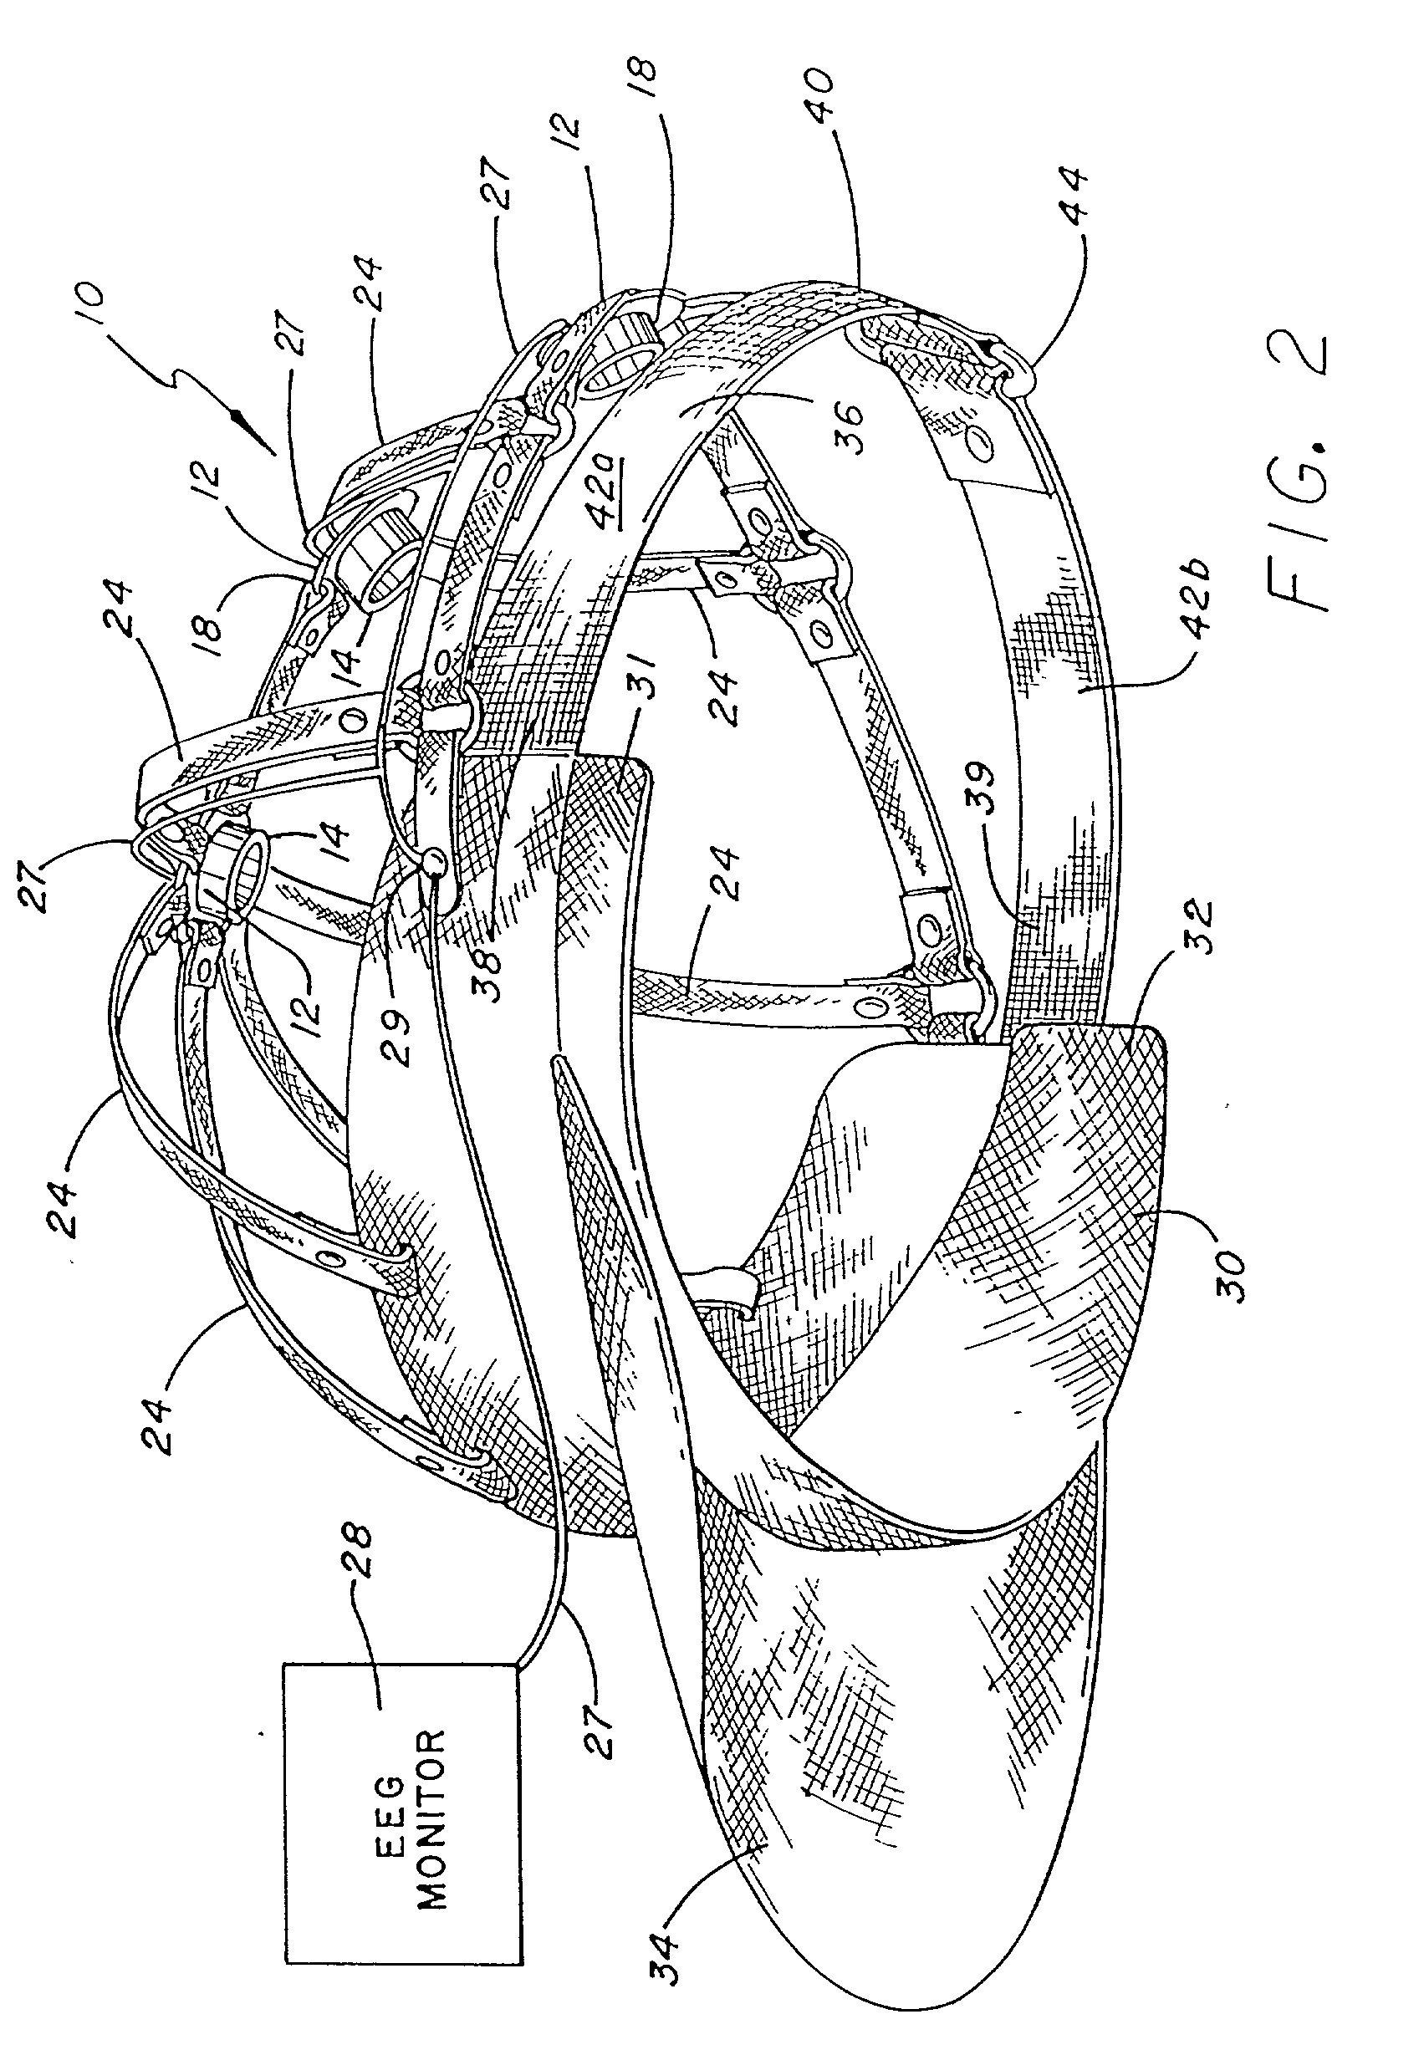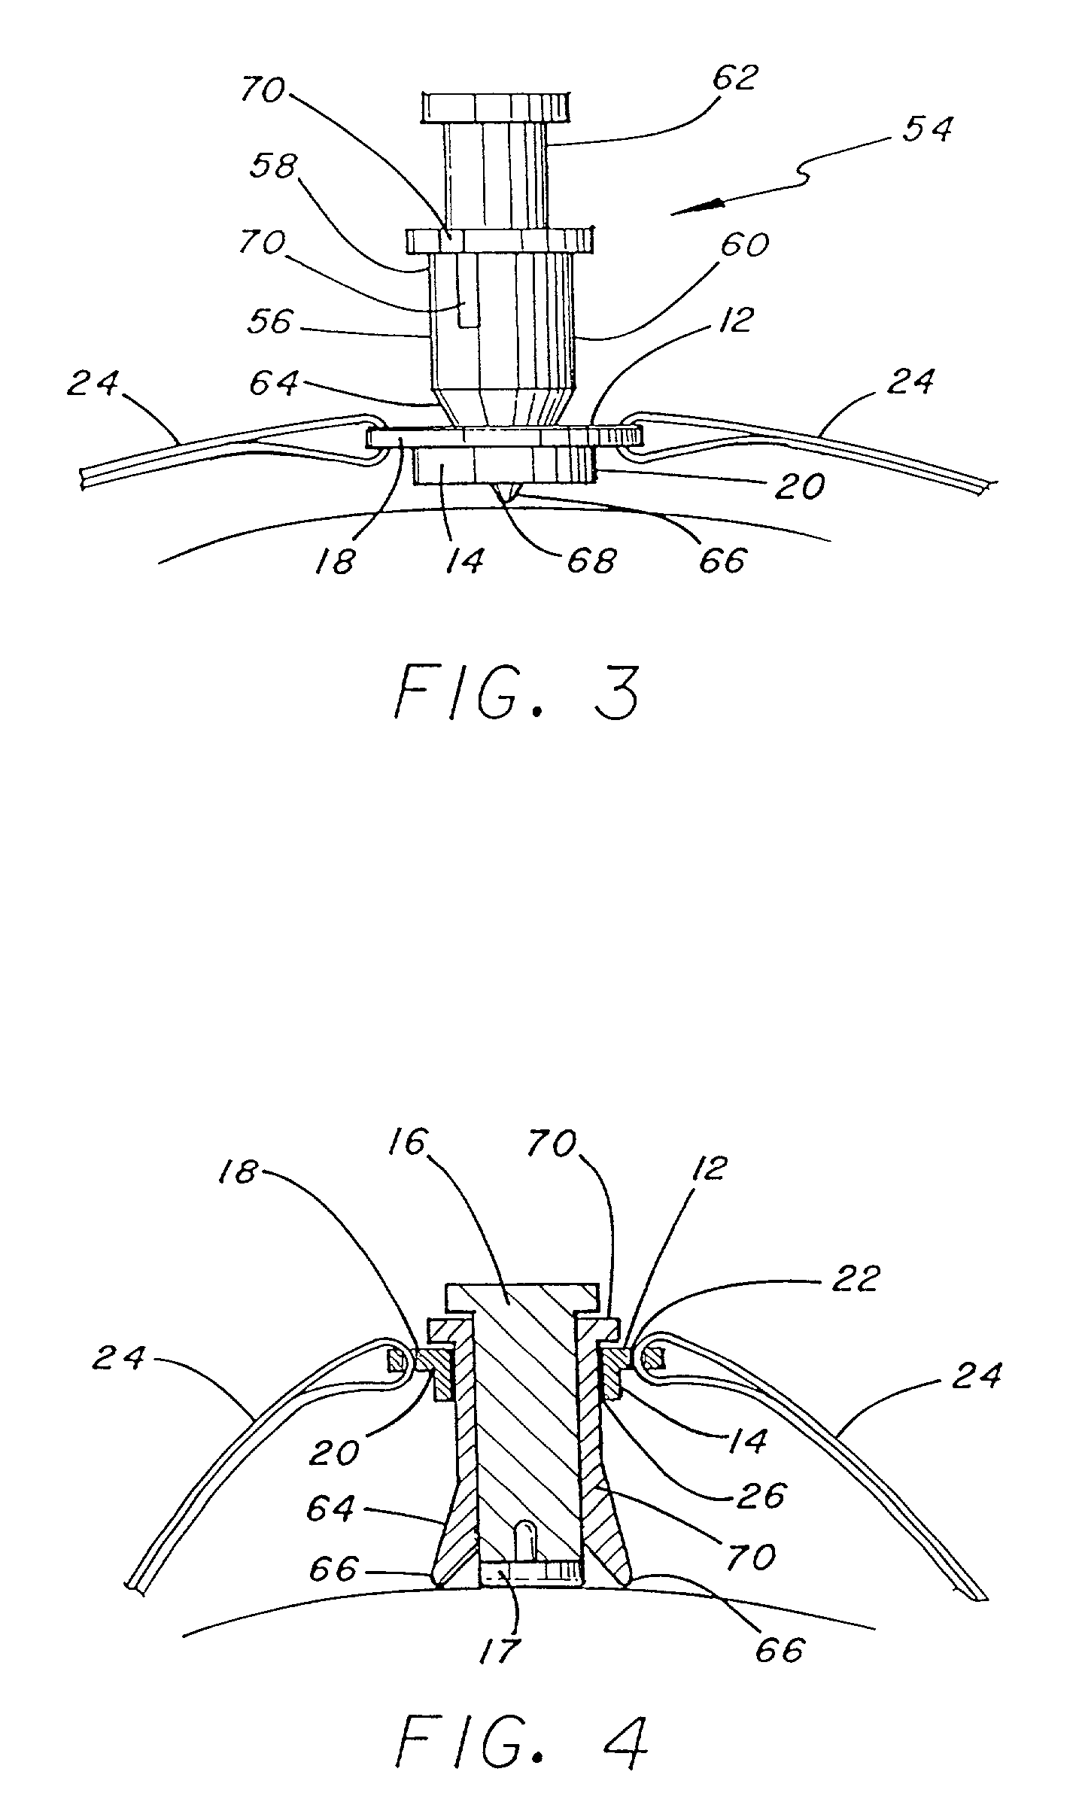

Figure 8: The EEG Electrode Locator Headgear that shows the straps that can be repositioned (left) and the plunger assembly (right) [15].(Patent: US6381481B1)

**Electrodes**

Electrode design is important to the function of our device. The job of the electrode is to conduct electrical current from the circuit to the scalp without generating contact resistance and therefore heat. This is done through the use of an electrolyte to conduct electric current evenly and safely without a metal on skin interface that can be hazardous to the epithelium. In tDCS current must be applied through the scalp which is typically covered in hair. For hairy areas a sponge electrode is favorable because adhesive electrodes cannot make contact with the skin.

Electrodes are placed on the montages to allow electric currents to flow safely from the device to the desired part of the brain. There are generally 3 types of electrodes that can be used for tDCS [21]. An example of them is adhesive electrode. This is the cheapest type among the three. It conducts current on the bare skin by easily just place it on the desired montage, but its current flow through hair could be disrupted. Another example is rubber carbon electrode. It is a bit more expensive than the adhesive electrode, and harder to prepare it because it requires gel application on the targeted area and needs a strap to prevent sliding from the position. Last example is the most prefered type for tDCS, the sponge electrode. It is the most expensive type among the three but it can conduct current through the hair by salinating the target area. This also needs a strap to hold it on the target area.

https://thebrainstimulator.net/choosing-electrodes/

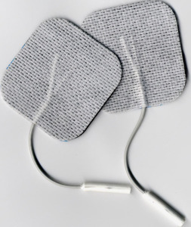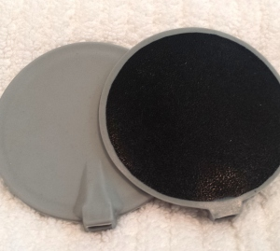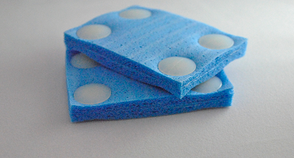

Figure 9: Electrode sponges [21],[14]

**Simple Circuit**

**Iontophoresis**

There are no single use or disposable tDCS devices on the market today. Most devices are actually costly and aren’t designed from a single use or usability standpoint. There however direct current medical devices on the market that do hit the intersection between disposability and effectiveness. Notably Iontophoresis devices like the IontoPatch® line [13] present a noteworthy solution to the problem of applying electric current to human skin. This device uses a small battery to provide a unregulated but relatively constant voltage on the skin to deliver drugs transdermally. The takeaway is that we should similarly use a small battery in an easy to use clean packaging that can be used with minimal instruction. There are however two critical problems for such a cheap and minimal circuit. One is that the power supply may provide a relatively constant voltage, but there is no real way to tell if the output current is correct or consistent between uses. Additionally there is a problem of how there is no dosing mechanism in terms of timing the dose. We can use this design as inspiration for how we can implement tDCS in a similar product



Figure 10: Iontophoresis patches (http://www.iontopatch.com/device.html?fbclid=IwAR06i6e6AbVL3-DXtS2AmJJ1UWTT3mbXqUSO0zvm7ziTf7nfbctIovuJ38I).

**Additional Patents**

Patent EP0327304A1 contains some relevant information on electrodes. The electrodes in the patent are fully disposable and have a longer shelf life than traditionally packaged electrodes. The electrodes are not usable for placement on the head because it is adhesive. We can however, get some ideas from the design of the electrode to incorporate into our device. A useful aspect of the design is the capability of holding the electrolyte, gel layer, and the the electrolyte composition.

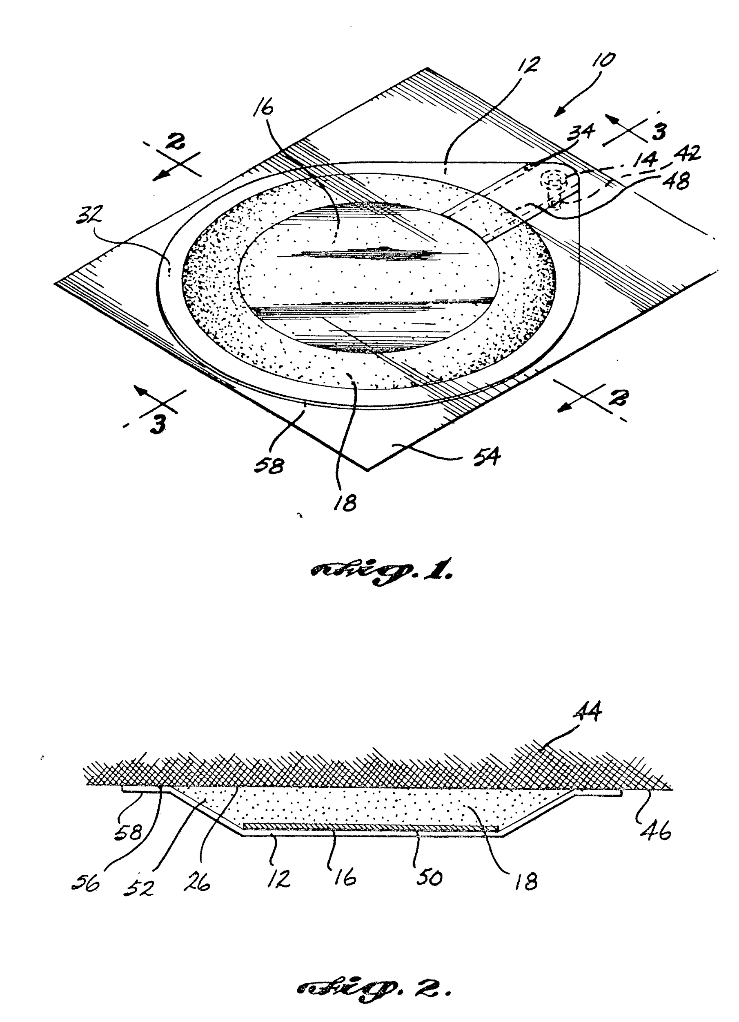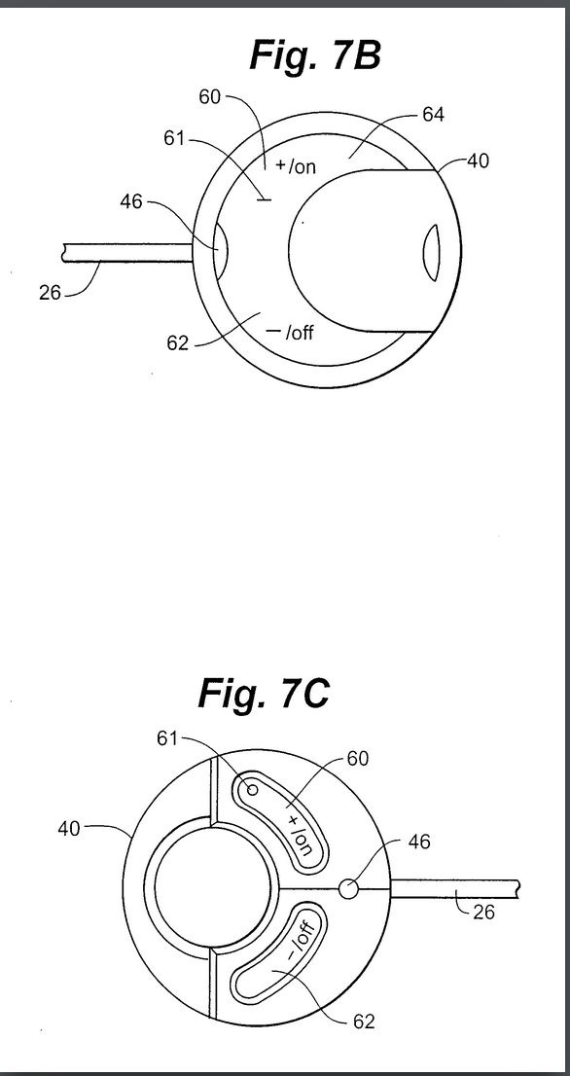

Figure 11: Patent US20100042180A1

Patent US20100042180A1 [31] describes a muscle stimulation device. The primary use is to alleviate pain. It provides pulsed current stimulation. It comes prepackaged with electrodes, on one electrode the circuitry is adhered to the body. This patent is notable because it claims to be disposable, the formfactor of the device and the low feature set agrees with this claim. However the lack of a description makes this claim somewhat unsubstantiated. The electrodes are also adhesive, which may pose a problem when looking at this device as a model for tDCS.

**Extended prior art chart:** <https://docs.google.com/spreadsheets/d/1QvFpyHunny0wdjKtE_laYSljv9ebk0Yvt6jh0VfexxI/edit?usp=sharing>

**Product Design Specification**

|  |  |
| --- | --- |
| **Parameter** | **Value** |
| Electrode size | 0.8 A/m2 current density must be maintained. So electrode pads of about 5cm x 5cm must be used above 2 milliamp current [34] |
| Current range | 2mA - 4 mA [9] (2mA is optimal) |
| Voltage | 20-43V [29] |
| Headgear circumference | 57.2 cm with adjustable material[10] |
| Weight | Less than 0.5 lb (compared with GoPro) |
| Length (enclosure) | Less than 6 in |
| Width (enclosure) | Less than 6 in |
| Height (enclosure) | Less than 6 in (based on previous devices) |
| Duration | 20 ~ 45 minutes |
| Cost | $20 |
| Ramp up/ down | 1mA/30s [31] |

1. Electrical Safety
   1. Current amplitude
      1. The current needs to below a certain limit to prevent skin and neural damage, up to 2 mA (milliamperes) DC.
      2. Current would be specified on the headgear with a label.
   2. Electrode interactions
      1. Electrodes must use an electrolyte, and the current must not pass through metal or rubber materials as this can cause undesirable chemical interactions. (<https://www.sciencedirect.com/science/article/pii/S1388245715010883>)
      2. Electrode size matters, high current (1mA) requires larger electrodes (larger than 4cm x 4cm).
      3. Long term exposure and excessive current can cause itching and redness and skin damage, electrical safety mechanism to automatically stop when current goes above 2 mA.
   3. Dosage
      1. Dosage should only last 20 ~ 45 minutes.

(<https://www.ncbi.nlm.nih.gov/pmc/articles/PMC2754807/>)

* 1. Safety precautions
     1. The device should come with simple and clear instructions on the device itself to prevent misuse. However, actual use of the device should be intuitive.
  2. Contact quality and material: electrodes connected to the sponge. Use fasteners to tighten it.
  3. Ramp up and down current
     1. gradually increasing current for safety. Increases by 0.05 mA before reaching actual current.

([https://academic.oup.com/ijnp/article/16/1/13/628505](https://academic.oup.com/ijnp/article/16/1/13/628505)))

* + 1. Few minutes before the session end the stimulation, it slowly lowers the current until it eventually powers down. (One use).
    2. 1 milliamp for every 30 seconds
  1. Voltage protection: the device has a voltage limit and would not exit reasonable voltage 60V according to section 3 of IEC 60601-1.

1. Low cost and environmental safety
   1. The targeted price range should be around 20 dollars
   2. The materials that should be used range from resistors, potentiometer, batteries, wires, pcb board, nfc chip. All are low cost.
   3. The circuit should be enclosed with fabric, plastic, or special paper to be safe to handle.
   4. Circuit should be protected from moisture of electrodes in individual package
2. Ergonomics:
   1. One person should be able to operate the device.
   2. Device has an option for powering on/off.
   3. The headgear is already attached to the circuit with no need to connect wires.
   4. Device is ready to go once opening.
   5. User should not have to think about pad placement and voltage. It should be hands free operation.
   6. Electrodes and cheap headgear needs to be designed for this device
      1. Headgear should accommodate different head sizes.
3. Size and Weight Restrictions:
   1. Weight should not exceed 0.5 lb (compared with GoPro)
   2. Length should not exceed 6 in.
   3. Width should not exceed 6 in.
   4. Height should not exceed 6 in.
   5. Dimensions represent the device enclosure.
4. User Interface Design
   1. Buttons/controls: Power/Start button, buttons for each duration/power (current).
      1. Sponsor has indicated that the duration and amperage for individual devices may not need to be changeable by user but by manufacturer.
   2. Packages clearly labeled with current rating.
   3. Device has a specific application.
   4. Montage specification
      1. Depression montage headgear should be sold with devices rated for specific currents.
      2. Packages are designed for individual use.
5. “Stretch“ goals
   1. User changeable current
      1. Our device should at least be able to have settings that can let the user choose current within safe range.
      2. Universal application depending on the complexity.
   2. Give user ability to change waveform.
   3. One important feature is sterilizability, if possible it should make the product stand out for uses in sterile environments like operation rooms (mentioned by sponsor).

**Brainstorming**

1. Using an NFC power supply.

Phones are typically able to provide around a couple milliamps of current through a coil used for NFC communications TDCs while being high voltage requires a low amperage. The power requirements may only be off by one order of magnitude if implemented properly a pulsing supply may be possible.

2. AC to DC amplifier ([Cockcroft–Walton generator](http://en.wikipedia.org/wiki/Cockcroft%E2%80%93Walton_generator))

<https://www.electronics-tutorials.ws/blog/voltage-multiplier-circuit.html> this schematic would be usedul in making the previous Idea work, we could step up the low AC voltage very high at the cost of the DC voltage dropping fast upon attaching a load. Instead of having a constant supply we could have a pulsing supply it could be just as effective, and it would not be dangerous according to some papers <https://www.ncbi.nlm.nih.gov/pubmed/26851768> pulsed current stimulation could be useful. It could also be made cheap

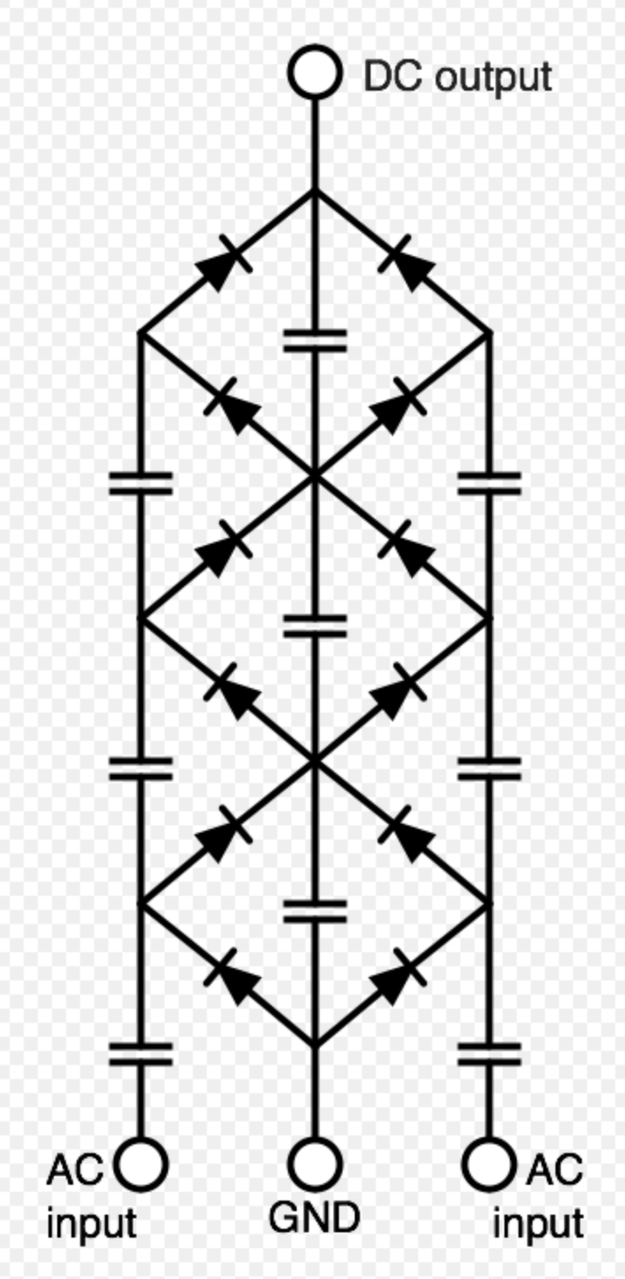

Figure 12: AC to DC amplifier

3. Headgear with straps

This idea could set the device apart in that we could make the headgear disposable by manufacturing it as a single sheet that assembles using easy to use snap on clips. We were thinking of using three layers, two plastic with a conductive layer underneath that can be pushed out of its perforations

4. Device mounted on the headgear

Instead of having the device connected to the wired electrodes, the patient can just put on the headgear and start the stimulation without complex setups.

5. Cap with built in electrodes

This kind of cap could be cheap user friendly in design and user experience if we mount the device on the head this might be the most comfortable

<https://www.google.com/search?q=tdcs+circuit&safe=active&source=lnms&tbm=isch&sa=X&ved=0ahUKEwicismTvtDeAhVhTt8KHX6nB2gQ_AUIEygB&biw=1440&bih=687#imgrc=vrffmuar-fZ_cM:>

6. Pronged/comb electrode

Most sponge electrodes work by being heavily soaked in electrolyte, this is difficult to package, so one idea is to use a porous comb that will directly touch the scalp with electrolyte instead of having a sponge soak the hair. This can be seen in figure 13.

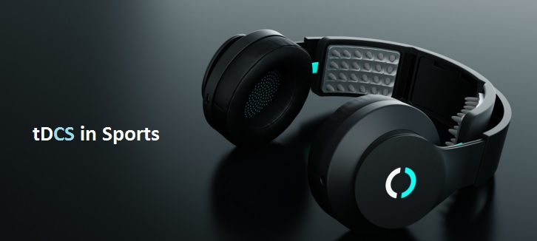

Figure 13: tDCS halo sport

7. Use a lot of coin cell batteries

Coin cell batteries can be quite cheap around 7 dollars for 20 (not in bulk: <https://www.amazon.com/d/Household-Batteries/Sony-CR2032-Lithium-Coin-Cell/B008XBK7PG> ) if we use 10 of them 3v each we can achieve high voltages without a need for an amplifier, eliminating the need for a complex

8. Use a DC to DC switching boost converter

This circuit design could produce a pulsed current at a higher voltage than the battery that could be used for pulsed tdcs. The principle is that by switching the circuit on and off by a JFET of a MOSFET voltage that can be developed across an inductor that can be put in series with the battery. It may not be able put a sustained current but a high current is necessary for the high impedance of the brain. No current modulation is done by this circuit

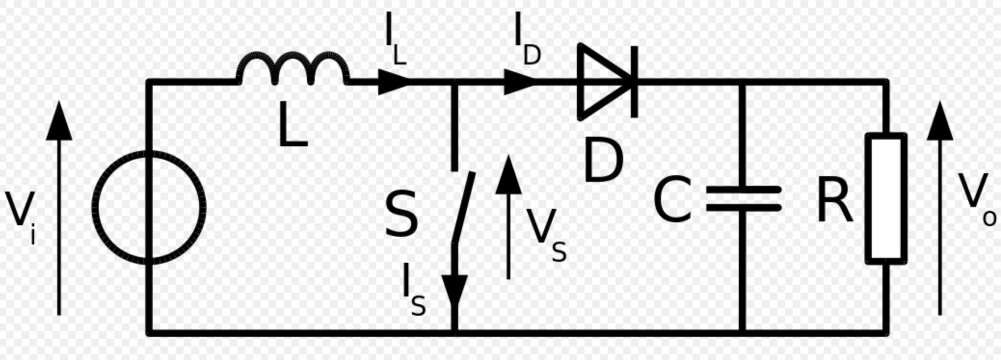

Figure 14: Circuit design for pulsed current

9. Another kind of boost converter can be made (Switched Capacitor )

This has a similar principle to the inductive boost converter however the waveform is different. For this circuit multiple stages would be needed for the tDCS application if no high voltage batteries are used. Current regulation is not done by this circuit

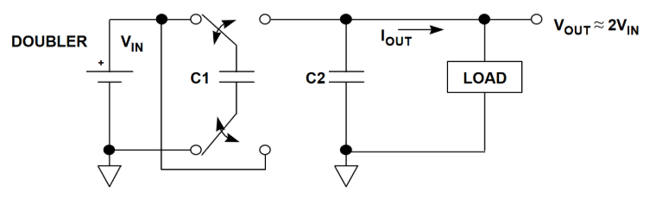

Figure 15: capacitive boost converter circuit

10. Constant current power supplies:

two main designs used in diy tDCS are accomplished using either with a NPN transistor or a voltage controlled voltage regulator. These designs come from commonly used circuits for DIY tDCS, One promising design is the inthinkerator [32]:

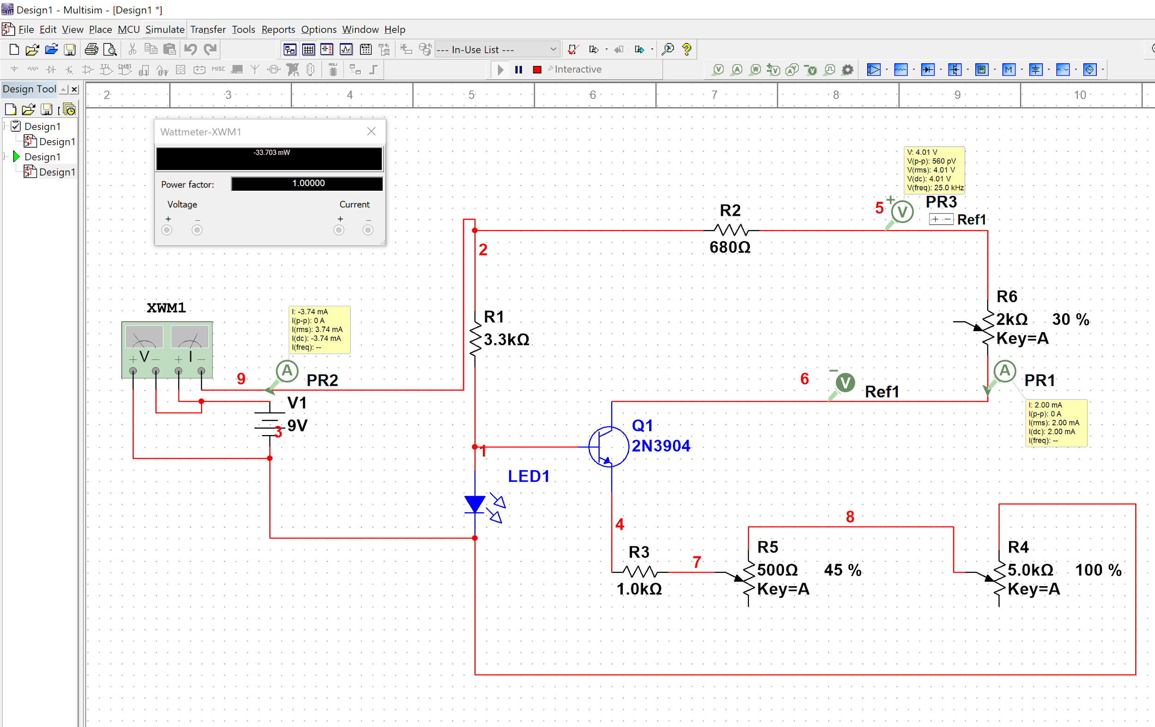

Figure 16: dc constant current supply using a BJT NPN transistor

This circuit is commonly used in the DIY tDCS community and the results are very promising. One thing that might be changed is the potentiometer component. The final design may only have one resistor to produce a steady current for one montage.

Price analysis: Online documentation stated that this Design would cost about 10$ including electrodes, an enclosure and auxiliary materials. The main component (the transistor) costs 6 USD on amazon in packs of 100 (https://www.amazon.com/Laqiya-100Pcs-General-Purpose-Transistor/dp/B01M309DB3/ref=sr_1_3?ie=UTF8&qid=1543641415&sr=8-3&keywords=2N3904)

Power analysis: using simulation we found that this circuit would draw about 33.7 mW (3.74 mA). Based on Duracell’s Datasheet (https://d2ei442zrkqy2u.cloudfront.net/wp-content/uploads/2016/03/MN1604_US_CT1.pdf) on their consumer 9V batteries, there is a 1 volt voltage drop for 2 milliamp current draw over 50 hours. We should then realistically expect that there will not be much of a voltage drop over a 40 minute dose.

There are also designs that utilize a voltage regulator to produce a constant current. This Design is another one used in the open source community, except it uses a voltage regulator instead of a transistor like the first design to manage the current, we found that this circuit, while simple does not supply a reasonable current. Though the current is in fact constant. We think more calculation might need to be done to see if there is a way to configure the voltage regulator so that it works.

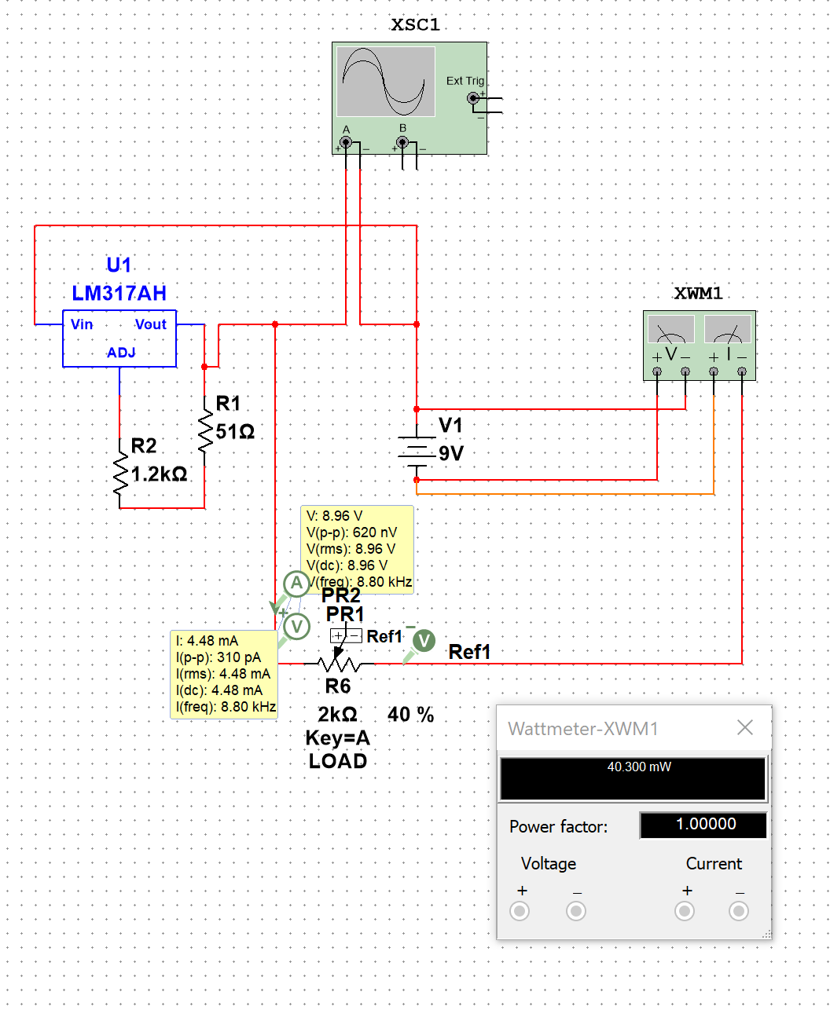

Figure 17: current control using a voltage regulator with feedback

Power analysis: This circuit draws around 40 watts at 4.48 mA. It Draws more current than the first type and that makes sense because it pushes more current through the load (resistance of the head).

**Controlling ramp-up and ramp-down**

1. Using an op amp.

Using an integrator circuit configuration of an op amp. The op amp can also be configured more simply as just a follower with diodes. The difference is that with an integrator circuit the final voltage will be closer to the goal voltage. However an integrator circuit would require two op-amps. Op amps cost around 1 dollar with variations according to the op amp accuracy.

Integrator type:

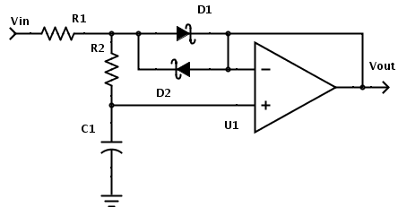

Figure 18: single op amp ramp circuit

Better ramp output, more cost (integrator with two op amps)

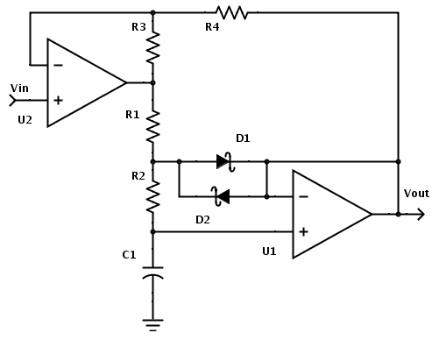

Figure 19: integrator ramp circuit

2. Ramp and timing using an ATtiny or 8 bit microcontroller

One way to control ramp and timing is to use a microcontroller like the ATtiny. This series of microcontroller costs around 44 cents ( <https://www.mouser.com/ProductDetail/Microchip-Technology/ATTINY402-SSFR?qs=sGAEpiMZZMve4%2fbfQkoj%252bGX0XzccGKC1pgqaSK2rGNY%3d> ). With an internal crystal timer the attiny can be configured with a digital potentiometer to modulate the output. Alternatively the output could be pulsewidth modulated with a transistor switching the output with the ATtiny and then smoothed.

**Brainstorming Concept Map**

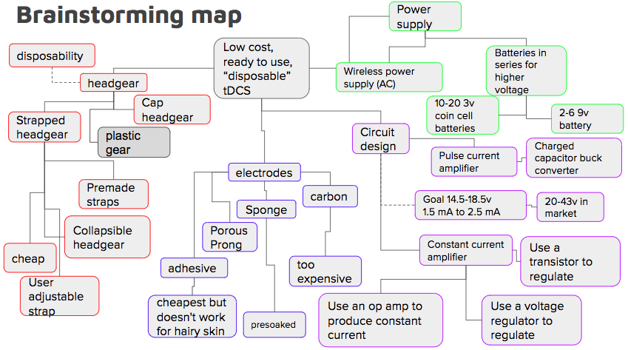

Figure 20: Brainstorming map

**Intellectual property claims**

1. Device will be disposable
2. Device will be extremely easy to use
   1. Patient should be able to self administer the medication
3. Device will be sterilizable*
4. Device will come in easy to open packaging
   1. It will be ready to use and pre assembled inside packaging unlike existing products
5. Device should output a steady current of 2 mA or less depending on the type of device used
6. The device should be usable for only one 15-30 minute dose and then safely deactivate
7. Headgear is easy to put on and use properly

* This aspect of the device may not be fulfilled in final design, however it is a goal

**Design Concepts**

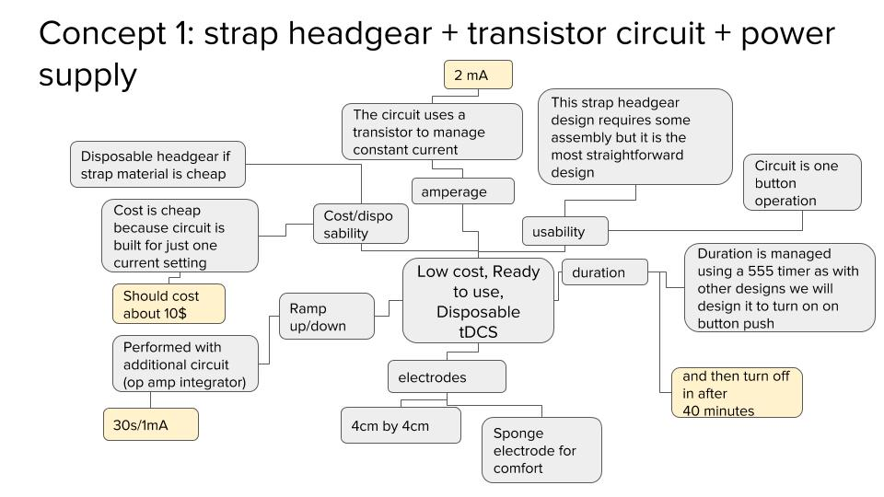

Figure 21: Concept 1

In this design a strapped headgear design with a circuit built using a single transistor and some passive components. This will lower the cost of the product. This design will also include a 555 timer to control dosage in terms of time, this design shows promising feasibility in hat the 555 circuit is well used in the diy and professional community. This circuit is also unique in that it proposes a headgear that uses snap together straps. The electrodes are not presoaked

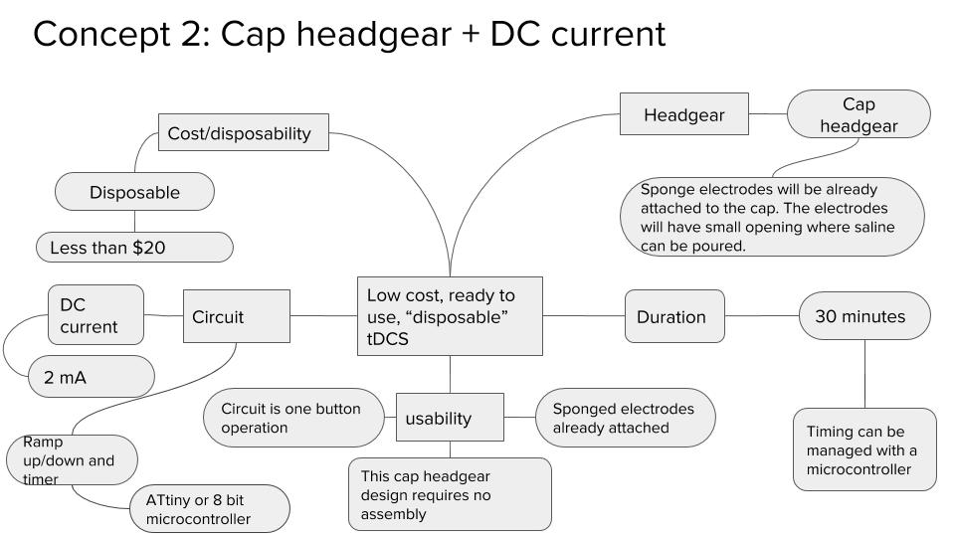

Figure 21: Concept 2

This design concept comprises of a hat [35] with embedded tdcs device and electrode. The device cost rounds up to about $20. The design has no to little preparation process. User is able to use this device by removing the adhesive patching from the surface of the sponge, putting the hat on and start the stimulation.

The hat will be adjustable between 55 to 59 cm circumference. Sponge electrode will be pre-attached to the hat, with small opening for users to apply saline before stimulation. Constant-voltage system in the circuit allows the device to operate continuously regardless of battery health. After 30-minutes of use, the device will slowly ramp down the current and power off the device. The device is completely disposable after use.

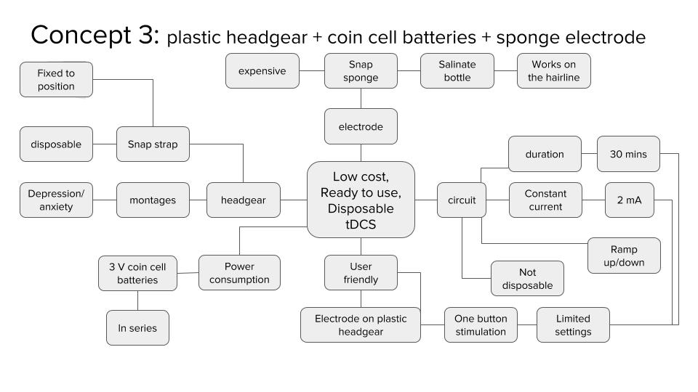

Figure 23: Concept 3

This concept is partially disposable design. The rigid plastic headgear (https://www.youtube.com/watch?v=LBYsY2arOrc) and the sponge electrodes are disposable, and the circuit and the 3V coin cell batteries are reusable. The headgear is affixed to the head with the spring tension of the headgear itself where the pressure of the headgear allows it to stimulate specific montage of depression and anxiety. The electrodes are pre soaked with saline which allows them to conduct current through the hairline. The circuit is preset to stimulate in 2 mA current for 30 minutes with ramp up and down to avoid possible shocking.

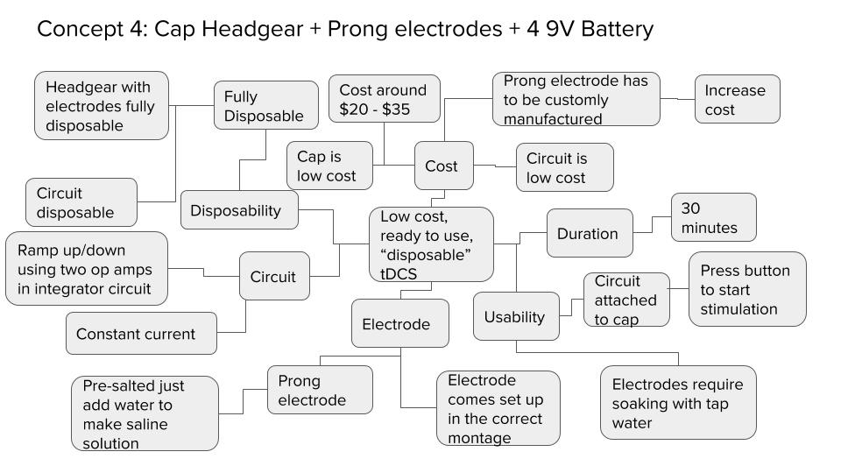

Figure 24: Concept 4

In this design prong electrodes are utilized, similar to the ones in the background. The prong electrode comes attached at the correct montage to the inside of the cap. The electrode is presalted and activated by applying tap water. The circuit comes in a separate container that is attachable via snap to the cap. The circuit is powered by 4 9V batteries that produces a steady current with a ramp up/down feature using two op amps. The cap, electrode, and circuit is fully disposable.

**Concept selection matrix**

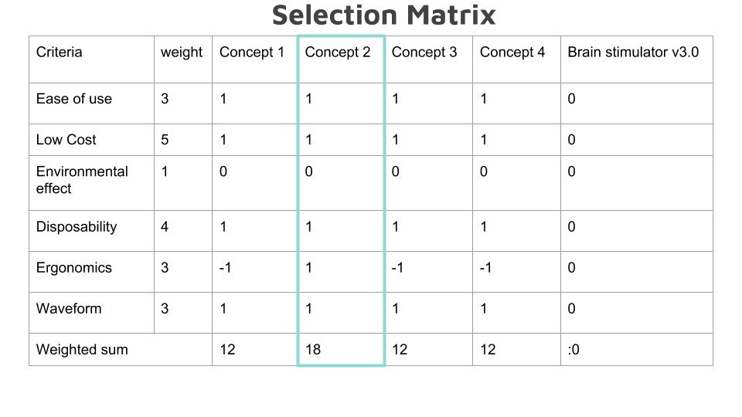

Concept 2 which includes a cap and a constant current power supply design was selected because we found it more ergonomic when compared to similar designs using a strap headgear. Concept 2 and concept 4 are quite similar however for concept 4 we chose a -1 for ergonomics. The reason being is that the prong electrodes create a concentrated current loading on the point sources from the prongs that make contact with the scalp. This causes discomfort in terms of a slight tingling/stinging sensation. The sponge electrode is preferred, in concept 2, over the prong electrode.

Price breakdown:

|  |  |  |  |
| --- | --- | --- | --- |
| Components | Unit Price | quantity | Price |
| Hat | $ 0.88 | 1 | $ 0.88 |
| Circuit box | $ 1.50 | 1 | $ 1.50 |
| Microcontroller | $ 0.44[37] | 1 | $ 0.44 |
| Power source (Battery design) | $ 1.00 (Duracell) | 4 | $ 4 |
| Power source  (voltage up circuit) | $ 9.99 (from amazon Drok brand) [36] | 1 | $ 9.99 |
| Saline Vial | $ 0.50 (15 mL) | 3 | $ 1.50 |
| Sponge electrode | $ 4 | 2 | $ 8 |
| Snap on pins | $.08 | 2 | $ 0.16 |
| Total |  |  | 16.48 / 26.48 |

**Discussion/Conclusion**

During the first semester of developing a disposable tDCS, we have made many realizations about both the problem at hand and possible approaches to the solution. To address the need for a disposable tDCS for the home consumer, we identified the critical product specifications of the problem. Critically current control, a safe voltage, a ramp up and ramp down, a comfortable headgear and a safe dose are critical to the function of this device. All these elements must come also at a low price, our goal being 20$.

Knowing these requirements, we developed and researched concepts to address each of these issues with electronic circuits, and overall headgear designs. Then we assembled complete concepts and then selected the concept that would best suit our needs with a concept selection matrix The design that won out has a “cap” headgear made from an off the shelf cap for mounting electrodes on to. In addition to the headgear we have a circuit built around a npn BJT transistor.

**References**

1. Shahbabaie A, Hatami J, Farhoudian A, Ekhtiari H, Khatibi A, Nitsche MA. Optimizing Electrode Montages of Transcranial Direct Current Stimulation for Attentional Bias Modification in Early Abstinent Methamphetamine Users. *Frontiers in Pharmacology*. 2018;9:907. doi:10.3389/fphar.2018.00907.
2. Bachtiar V, Johnstone A, Berrington A, et al. Modulating Regional Motor Cortical Excitability with Noninvasive Brain Stimulation Results in Neurochemical Changes in Bilateral Motor Cortices. *The Journal of Neuroscience*. 2018;38(33):7327-7336. doi:10.1523/JNEUROSCI.2853-17.2018.
3. Nasseri P, Nitsche MA, Ekhtiari H. A framework for categorizing electrode montages in transcranial direct current stimulation. *Frontiers in Human Neuroscience*. 2015;9:54. doi:10.3389/fnhum.2015.00054.
4. Thair H, Holloway AL, Newport R, Smith AD. Transcranial Direct Current Stimulation (tDCS): A Beginner’s Guide for Design and Implementation. *Frontiers in Neuroscience*. 2017;11:641. doi:10.3389/fnins.2017.00641.
5. “What Is TDCS - Learn About Neurostimulation.” The Brain Stimulator TDCS Devices. Retrieved Oct. 20. 2018, from thebrainstimulator.net/what-is-tdcs/.
6. “Managing Stress and Anxiety.” Anxiety and Depression Association of America, ADAA. Retrieved Oct. 20. 2018, from adaa.org/living-with-anxiety/managing-anxiety.
7. “Depression.” Anxiety and Depression Association of America, ADAA. Retrieved Oct. 20. 2018, from adaa.org/understanding-anxiety/depression.
8. Bikson M, Datta A, Elwassif M. Establishing safety limits for transcranial direct current stimulation. *Clinical neurophysiology : official journal of the International Federation of Clinical Neurophysiology*. 2009;120(6):1033-1034. doi:10.1016/j.clinph.2009.03.018.
9. Bikson M, Grossman P, Thomas C, et al. Safety of Transcranial Direct Current Stimulation: Evidence Based Update 2016. Brain Stimul. 2016;9(5):641-661.
10. Neyzi O, Bundak R, Gökçay G, et al. Reference Values for Weight, Height, Head Circumference, and Body Mass Index in Turkish Children. *Journal of Clinical Research in Pediatric Endocrinology*. 2015;7(4):280-293. doi:10.4274/jcrpe.2183.
11. Riggall, K., et al. “Researchers' Perspectives on Scientific and Ethical Issues with Transcranial Direct Current Stimulation: An International Survey.” *Brain Stimulation*, vol. 8, no. 2, 2015, p. 360., doi:10.1016/j.brs.2015.01.160.
12. “Facts & Statistics.” Anxiety and Depression Association of America, ADAA. Retrieved Oct. 21. 2018, from adaa.org/about-adaa/press-room/facts-statistics.
13. Yanaki, Jamal S. "Active transdermal medication patch and circuit board for same." U.S. Patent No. 8,862,223. 14 Oct. 2014.
14. Soterix Medical. Research/1x1/Accessories/1x1-easypad. Retrieved Oct. 21. 2018, from http://soterixmedical.com/research/1x1/accessories/1x1-easypad.
15. Levendowski, Daniel, et al. *Portable EEG Electrode Locator Headgear*. Patent No. US20020029005A1. 7 Mar. 2002.
16. Tyler, William J., et al. "Transdermal neuromodulation of noradrenergic activity suppresses psychophysiological and biochemical stress responses in humans." Scientific reports 5 (2015): 13865.
17. Biology Of Depression - Neurotransmitters.” Mental Help Early Childhood Cognitive Development Language Development Comments, www.mentalhelp.net/articles/biology-of-depression-neurotransmitters/.

#### "Thync Device - Google Search." *Google.com*. N. p., 2018. Web. 11 Oct. 2018.

1. "The Brain Stimulator - Cranial Stimulation Devices." *The Brain Stimulator tDCS Devices*. N. p., 2018. Web. 16 Oct. 2018.
2. Mohammadi* A. Induction of Neuroplasticity by Transcranial Direct Current Stimulation . *Journal of Biomedical Physics & Engineering*. 2016;6(4):205-208.
3. “What Is Transcranial Direct-Current Stimulation (TDCS)?” *NEUROMODEC*, neuromodec.com/what-is-transcranial-direct-current-stimulation-tdcs/.
4. The Brain Stimulator tDCS Devices. Choosing The Right Electrodes for tDCS. Retrieved Oct. 22. 2018, from <https://thebrainstimulator.net/choosing-electrodes/>
5. Ciechanski, P., et al. "Effects of transcranial direct‐current stimulation on laparoscopic surgical skill acquisition." BJS Open 2.2 (2018): 70-78.
6. Choe, Jaehoon, et al. "Transcranial direct current stimulation modulates neuronal activity and learning in pilot training." Frontiers in human neuroscience 10 (2016): 34.
7. Sample, Ian. "US Military Successfully Tests Electrical Brain Stimulation To Enhance Staff Skills." the Guardian. N. p., 2016. Web.15 Oct. 2018.
8. “TDCS Electrode Placement Montage Guide - Total TDCS.” *Total TDCS Electrode Placement Montage Guide*, totaltdcs.com.
9. https://www.ebay.com/itm/4mA-Transcranial-Direct-Current-Stimulation-TDCS-DIY-ELECTRODES-HEADBAND/292758679611?hash=item4429c6f03b:g:CaEAAOSwa3BZ~2h1:rk:9:pf:0
10. <https://www.ebay.com/itm/Transcranial-Direct-Current-Stimulation-TDCS-DIY-from-0-2-to-2mA/292751912473?_trkparms=aid%3D888007%26algo%3DDISC.MBE%26ao%3D1%26asc%3D20131227121020%26meid%3De1863033c909414289f9c2b049f358e7%26pid%3D100009%26rk%3D1%26rkt%3D1%26sd%3D292758679611%26itm%3D292751912473&_trksid=p2047675.c100009.m1982>
11. DIY | DIY Tdcs | Page 2." Diytdcs.com. N. p., 2015. Web. 15 Oct. 2018.
12. “Methods for Extra-Low Voltage Transcranial Direct Current Stimulation: Current and Time Dependent Impedance Decreases.” NeuroImage, Academic Press, 29 Sept. 2012, [www.sciencedirect.com/science/article/pii/S1388245712005962](http://www.sciencedirect.com/science/article/pii/S1388245712005962).
13. Gomez-tames J, Sugiyama Y, Laakso I, et al. Effect of microscopic modeling of skin in electrical and thermal analysis of transcranial direct current stimulation. Phys Med Biol. 2016;61(24):8825-8838.
14. Thair H, Holloway AL, Newport R, Smith AD. Transcranial Direct Current Stimulation (tDCS): A Beginner's Guide for Design and Implementation. *Front Neurosci*. 2017;11:641. Published 2017 Nov 22. doi:10.3389/fnins.2017.00641
15. <https://www.dropbox.com/s/x0xvr4qzj9fz5v1/inthinkeratormkIrev2_guide.pdf?dl=0>
16. Brunoni AR, Nitsche MA, Bolognini N, et al. Clinical research with transcranial direct current stimulation (tDCS): challenges and future directions. *Brain Stimul*. 2011;5(3):175-195.
17. <https://www.youtube.com/watch?v=UW1DnpEKiNs>
18. <https://www.amazon.com/Converter-DROK-Transformer-Constant-Current/dp/B075DFBTRM>
19. https://www.mouser.com/ProductDetail/Microchip-Technology/ATTINY402-SSFR?qs=sGAEpiMZZMve4%2fbfQkoj%252bGX0XzccGKC1pgqaSK2rGNY%3d